## Configuration Control Board

It’s appropriate for this project to have a Configuration Control Board (CCB). The CCB will manage propose changes to the system throughout the development stage. The CCB board will handle any configuration item changes, such as source code, test cases or design documentation. Since our team is relatively small, a group of six, we will have equal say in the CCB to formally approve or deny any changes. Mr. Delgado, V & V, will be our deciding factor and lead when a member of our team proposes a change to any of the configuration items. A breakdown of our CCB is as follows:

**CCB Structure**

Arturo Delgado, V&V will be our lead

Joseph Aguirre, Programmer 1, point of contact for submitting changes

Andre De La Cruz, Analyst, will handle record keeping

Jesus Tabares, Juan Rodriguez, Xavier Thomas will access the risk and impact of a propose change

**CCB Responsibility**

Management of configuration items

Approve or deny any propose changes to the system

Notify the member when propose change to his component

Keep historic record of all changes, approved or denied

Risk and impact assessment

**CCB Management of Propose Changes**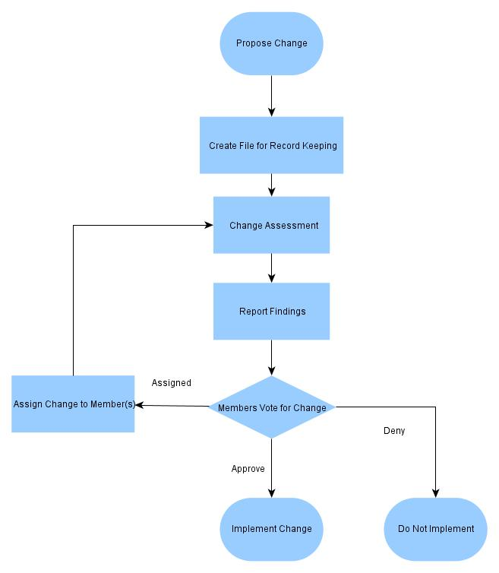

**Propose Changed**

Any member of our team can propose a change to any of the artifacts or configuration item. A proposal will be submitted to Mr. Aguirre. Mr. Aguirre will notify Mr. Delgado and Mr. De la Cruz.

**Create File**

Mr. De La Cruz will create a working copy on our directory and a proper document describing the problem and a possible solution.

**Change Assessment**

Mr. Tabares, Mr. Rodriguez and Mr. Thomas will evaluate the configuration item and determined based on the facts the propose change will accommodate the existing baseline of our progress. They will also determine if the new item is feasible and other component of the system will have minimal or no impact because of this change.

**Report of Findings**

A report of the assessment will be presented on a CCB session set up by Mr. Delgado. Two members of the assessment team must be present and Mr. Aguirre or Mr. Delgado will take lead of this meeting. Overall goal of this meeting is to acknowledge the change is paramount to the success of the system. Objectives for this meeting will be to discuss risk to the system. Considerations of time management and resource will be taking into account even if we all agree the change is beneficial. Another objective is to compare both components and weigh their benefits against each other. Based on the findings members will express their expertise and cast a vote.

**Members Vote**

Members will publicly cast a vote for a change on item. If the vote is 3-2, Mr. Delgado will be the deciding the factor. The body of the group will decide who will get the task to make the changes. Members can volunteer their time and make recommendations as well. If the change is approved, the responsible member will implement the change to the working system.

**Assignment**

Member(s) assigned the task to make the changes will work with the copy in our directory. The copy will be assessable to all members. After the changes have been made they will be submitted for another assessment.